**Ch4 P11.**

* Interface 0: 0000 0000 – 0011 1111
  + Addresses = 2^6 = 64
* Interface 1: 0100 0000 – 0101 1111
  + Addresses = 2^5 = 32
* Interface 2: 0110 0000 – 0111 1111
  + Addresses = 2^6 + 2^5 = 64 + 32 = 96
* Interface 2: 1000 0000 – 1011 1111
  + Combined above
* Interface 3: 1100 0000 – 1111 1111
  + Addresses = 2^6 = 64

**Ch4 P13.**

We first fix the first 3 bytes, 223.1.17 as per the requirement

* We need 6 bits for at least 60 addresses, hence subnet 1 = 223.1.17.0/26
* We need 7 bits for at least 90 addresses, hence subnet 2 = 223.1.17.128/25
* We need 4 bits for at least 60 addresses, hence subnet 3 = 223.1.17.192/28

Ch4 P21.

1. Home network interfaces can have addresses 192.168.1.1, 192.168.1.2, 192.168.1.3 and the router can have 192.168.1.4

|  |  |
| --- | --- |
| WAN | LAN |
| 24.34.112.235, 4000 | 192.168.1.1, 3345 |
| 24.34.112.235, 4001 | 192.168.1.1, 3346 |
| 24.34.112.235, 4002 | 192.168.1.2, 3345 |
| 24.34.112.235, 4003 | 192.168.1.2, 3346 |
| 24.34.112.235, 4004 | 192.168.1.3, 3345 |
| 24.34.112.235, 4005 | 192.168.1.3, 3346 |

Ch4 P26.

|  |  |  |  |  |  |  |  |  |  |  |  |  |  |
| --- | --- | --- | --- | --- | --- | --- | --- | --- | --- | --- | --- | --- | --- |
|  |  | **t** | | **u** | | **v** | | **w** | | **y** | | **z** | |
|  |  | **Distance** | **Source** | **Distance** | **Source** | **Distance** | **Source** | **Distance** | **Source** | **Distance** | **Source** | **Distance** | **Source** |
| init |  | inf | - | inf | - | inf | - | inf | - | inf | - | inf | - |
| 0 | x | inf | - | inf | - | 3 | x | 6 | x | 6 | x | 8 | x |
| 1 | xv | 7 | v | 6 | v | 3 | x | 6 | x | 6 | x | 8 | x |
| 2 | xvu | 7 | v | 6 | v | 3 | x | 6 | x | 6 | x | 8 | x |
| 3 | xvuw | 7 | v | 6 | v | 3 | x | 6 | x | 6 | x | 8 | x |
| 4 | xvuwy | 7 | v | 6 | v | 3 | x | 6 | x | 6 | x | 8 | x |
| 5 | xvuwyt | 7 | v | 6 | v | 3 | x | 6 | x | 6 | x | 8 | x |
| 6 | xvuwytz | 7 | v | 6 | v | 3 | x | 6 | x | 6 | x | 8 | x |

Ch 5 P2.

True matrix:

|  |  |  |  |  |  |
| --- | --- | --- | --- | --- | --- |
| 0 | 0 | 0 | 0 | 0 | 0 |
| 0 | 1 | 1 | 0 | 1 | 1 |
| 1 | 0 | 1 | 0 | 1 | 1 |
| 1 | 1 | 1 | 1 | 1 | 1 |
| 0 | 0 | 1 | 1 | 1 | 1 |
| 0 | 0 | 0 | 0 | 0 | 0 |

Single bit error in row 2, column 2:

|  |  |  |  |  |  |
| --- | --- | --- | --- | --- | --- |
| 0 | 0 | 0 | 0 | 0 | 0 |
| 0 | 1 | 1 | 0 | 1 | 1 |
| 1 | 0 | 0 | 0 | 1 | 1 |
| 1 | 1 | 1 | 1 | 1 | 1 |
| 0 | 0 | 1 | 1 | 1 | 1 |
| 0 | 0 | 0 | 0 | 0 | 0 |

We detect that there’s an error and know exactly which bit

Double bit error in row 3, columns 0 and 1:

|  |  |  |  |  |  |
| --- | --- | --- | --- | --- | --- |
| 0 | 0 | 0 | 0 | 0 | 0 |
| 0 | 1 | 1 | 0 | 1 | 1 |
| 1 | 0 | 1 | 0 | 1 | 1 |
| 0 | 0 | 1 | 1 | 1 | 1 |
| 0 | 0 | 1 | 1 | 1 | 1 |
| 0 | 0 | 0 | 0 | 0 | 0 |

We detect that there’s an error but don’t know exactly which row since the 2 bit errors cancelled each other as far as that row’s parity is concerned.

Ch5 P5.

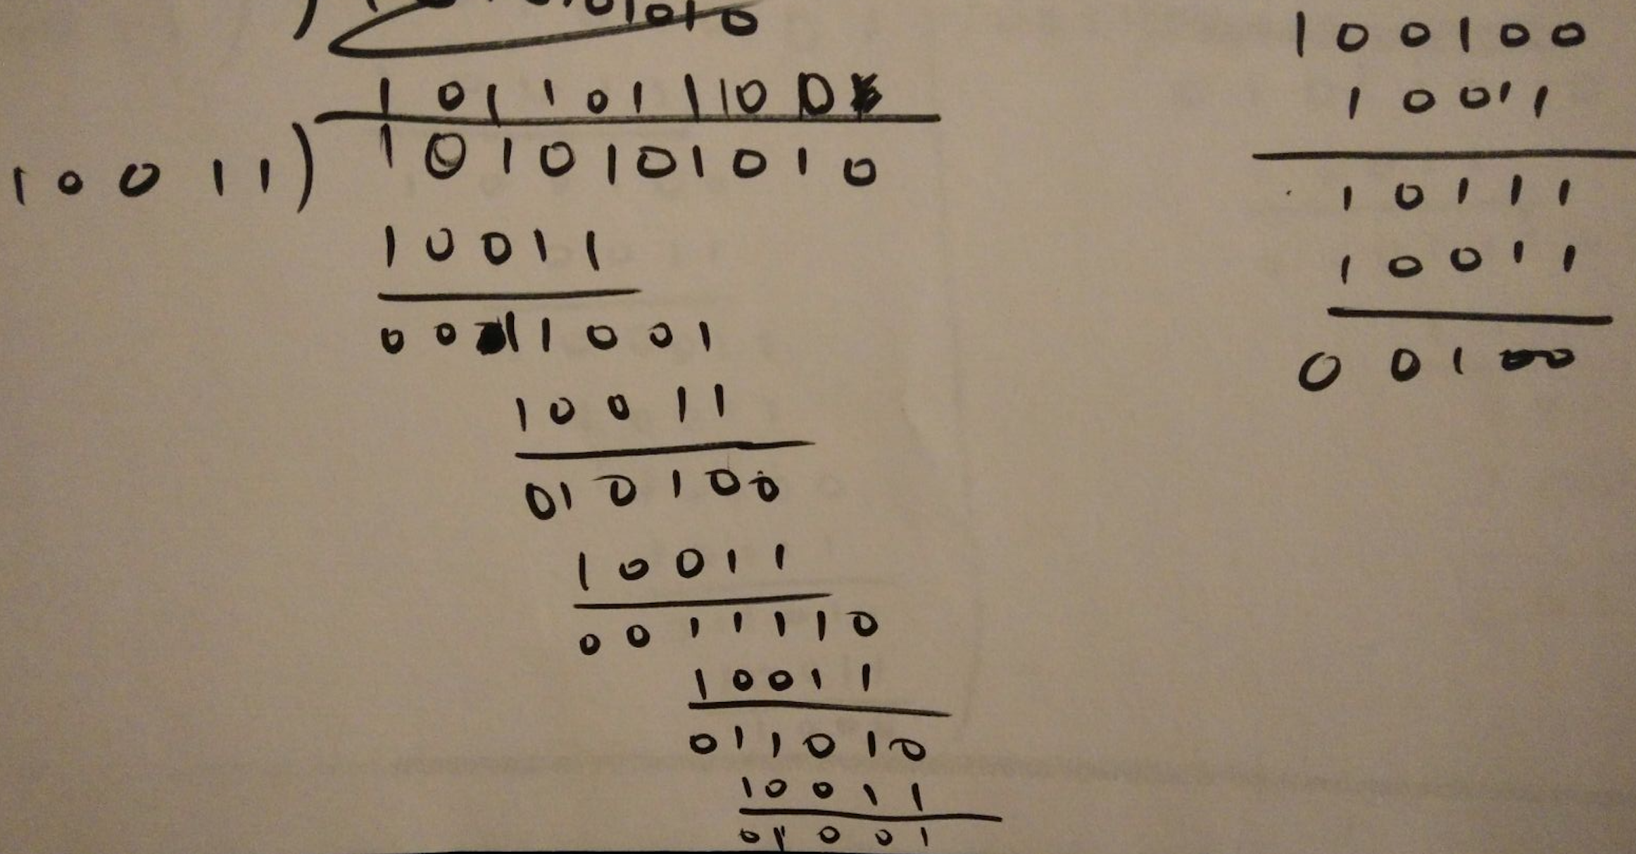

From the above calculation, we see that the quotient is 1011011100 and R = 100

Ch5 P15.

a and b.

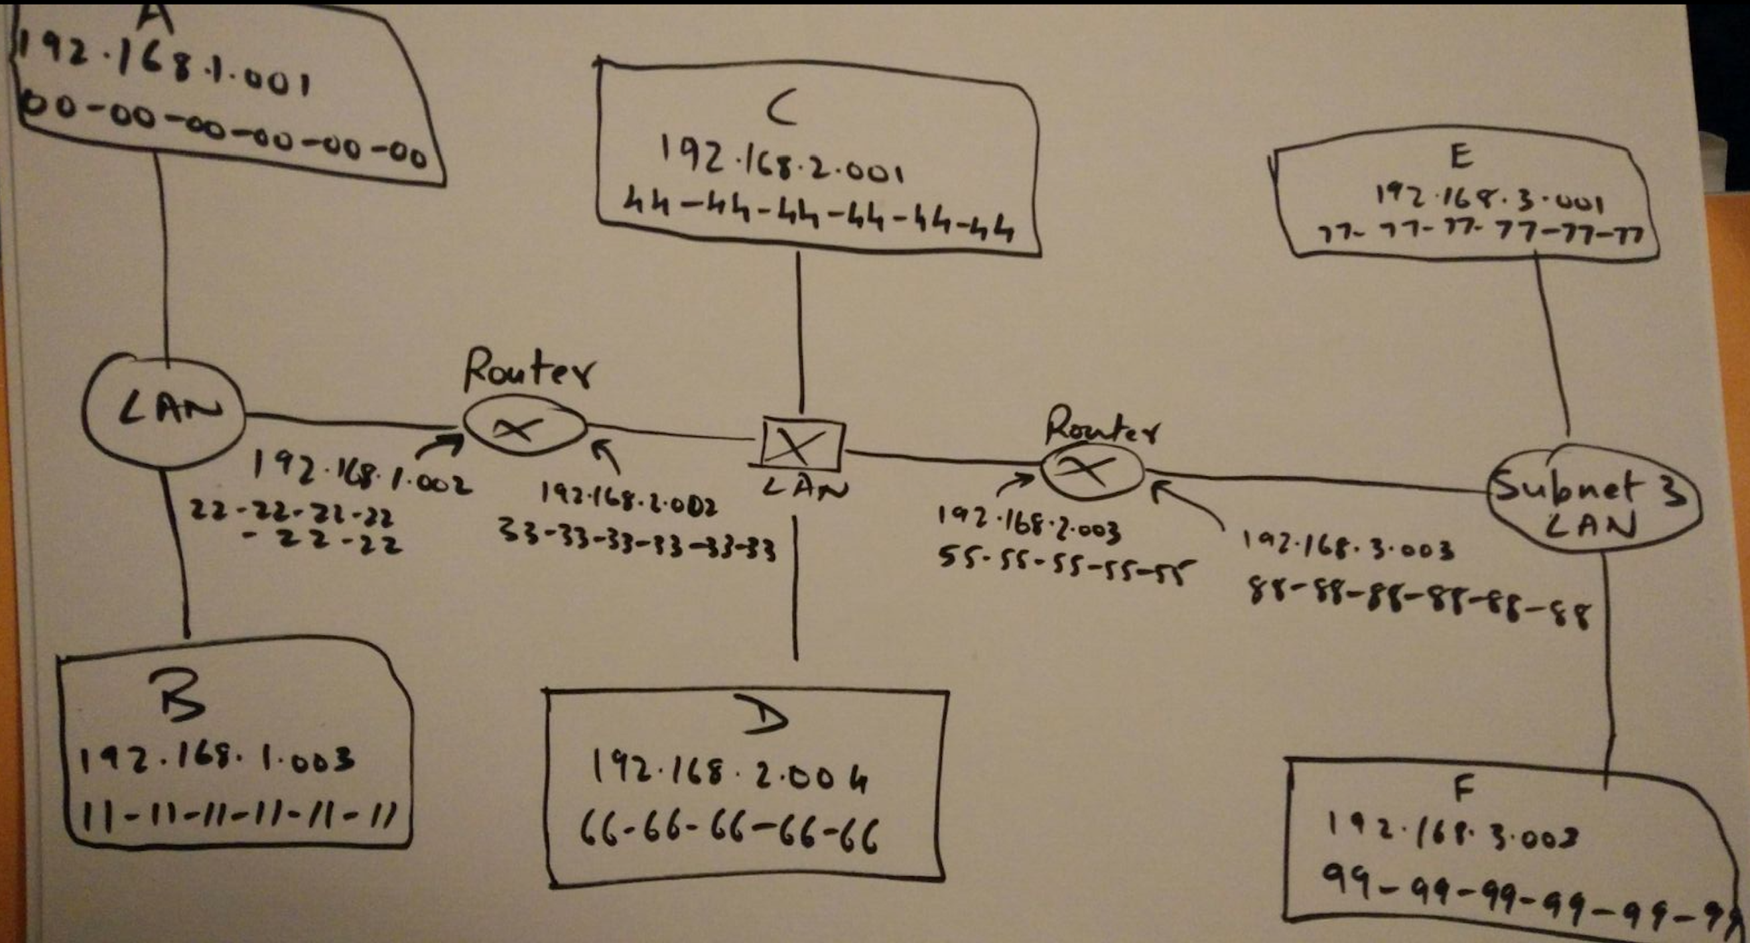

We’re given that the ARP tables are up to date, so host E to host B will be as follows:

* E knows from its forwarding table that the datagram needs to be routed to interface 192.168.3.002
* The adapter sends an Ethernet packet with destination 88-88-88-88-88-88, which is nothing but the right-hand side router
* The router extracts the datagram
* It knows from its forwarding table that the datagram needs to be routed to 192.168.2.002
* It sends an Ethernet packet with destination 33-33-33-33-33-33 and source IP 192.168.2.003 and source address of 55-55-55-55-55-55
* This is the left-hand side router. It knows from its forwarding table that the datagram needs to be routed to 192.168.1.003
* It sends an Ethernet packet with destination 11-11-11-11-11-11 and source IP 192.168.1.002 and source address of 22-22-22-22-22-22
* The packet is at the destination.
* E’s ARP must know what the MAC address of 192.168.3.002 is
* It sends a broadcasts frame with an ARP query packet within.
* The right-hand side router catches hold of this frame.
* It sends an ARP response packet with destination 77-77-77-77-77-77 to E.
* Since other tables are up to date, we’re good.
* The process is same as above after this.